**User Manual for Digital Farmington Map**

**Version:** 1.0  
**Date:** 05/01/2024  
**Prepared by:** DevMavericks

**Table of Contents**

1. **Introduction**
   * Purpose of This Manual
   * Overview of Digital Farmington Map
   * Audience
2. **Getting Started**
   * System Requirements
   * How to Access the Web Application
3. **Features Overview**
   * POI Manager
   * Category Manager
   * Admin Manager
4. **Detailed User Guide**
   * How to [Perform Task 1]
   * How to [Perform Task 2]

**1. Introduction**

**Purpose of This Manual**

This manual aims to provide comprehensive instructions on how to effectively use Digital Farmington Map. It serves as a resource for new users and a reference for experienced users.

**Overview of Digital Farmington Map**

Digital Farmington Map is a web application that displays a map of the Farmington Valley with Point of Interests (POIs) from 1610 to 2020. These POIs are classified into various categories which allows users to filter out the POIs displayed on the map based on the category/categories selected. It also has a slider with the year range, which allows users to select which particular year to view the POIs.

**Audience**

This manual is designed for users who have access to the admin page of the Digital Farmington Map. **The features discussed are also limited to admin users only**.

**2. Getting Started**

**System Requirements**

* Any Internet Browser. e.g., Chrome, Firefox, Safari, etc
* Internet Access

**How to Access the Web Application**

To access the homepage, type the following URL link into the search bar of your web browser:

<https://digitalfarmingtonmap.org/>

To get to the admin page, right-click on the Admin Login on the homepage.

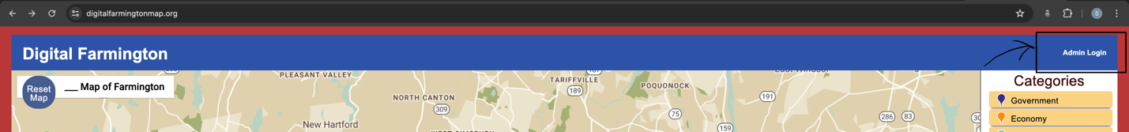

Once on the Admin Login page, enter your login information and login to get access to the admin features.

**3. Features Overview**

**POI Manager**

The POI manager allows the user to create, edit, update and delete new or existing POIs. Changes made in the POI manager updates the database and immediately displays them on the Map. It also allows the user to view all POIs in the database. Users can access this page by right-clicking the POI Manager tab at the top of the map or current page.

**Category Manager**

The Category Manager displays a list of categories created for the map. Users can create new categories, make changes to existing categories and also delete them. To access this page, the user must right-click on the Category Manager tab at the top of the map or current page.

**Admin Manager**

The Admin Manger displays all current admins in the database. This page allows admin users to create new admin accounts. To access this page, right-click on the Admin Manager tab on top of the map or the current page.

